HOW TO PAY BY CHOOSING YOUR OWN AMOUNT

STEP 1

- Fill in your name, email and choose the training you want to pay for
- Click the button "Click here to choose the amount to pay"

STEP 2

- A new form opens. Type in the amount you want to pay on the left side underneath the Product name ISTA TRAINING

STEP 3

- Confirm your payment by clicking the button ZAHLEN (meaning pay - our German website allows no change of language here)

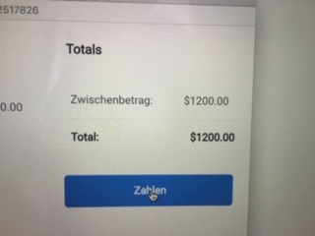

HAVING PROBLEMS? Try the following:

* Change your WIFI network (some WIFI networks don´t support payments)
* Change your browser
(sometimes changing from Apple Safari to Google Chrome makes a difference)

